Reading the Whois Database

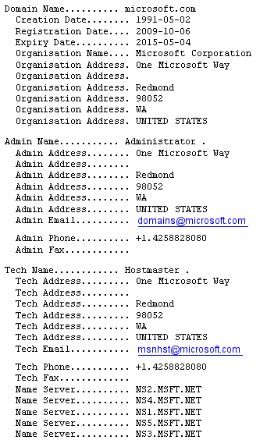 | Website name  When it was created  When it expires  Owner  Owner’s address  Website administrator  Administrator’s address  Administrator’s e-mail  Administrator’s phone  Technical Contact  Tech’s address  Tech’s e-mail  Tech’s phone

[This page intentionally left blank.]

